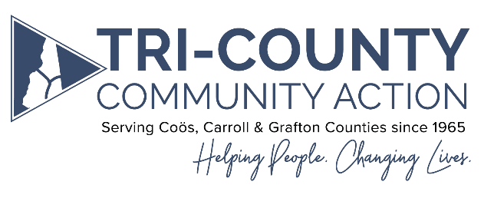

Welcome!
Thank you for your interest in joining the Tri-County Community Action Board of Directors.
Tri-County Community Action Program, Inc., (TCCAP) is a 501(c)(3) organization dedicated to providing health and human services in Coos, Carroll and Grafton Counties. Our mission is to provide opportunities to strengthen communities by improving the lives of low to moderate income individuals and families. Our vision for the future is that individuals and families are empowered to create vibrant communities and foster self-sufficiency.
As a prospective Board Member, here are some quick facts to give you an overview of the organization and the work we do in the communities we serve:
- Tri-County Community Action Program was incorporated on May 18th, 1965 and is one of 1,000 Community Action Agencies nationwide that provide a similar scope of services.
- Tri-County CAP is one of five Community Action Agencies serving the state of New Hampshire.
- Our programs are organized under three major departments: Health and Nutrition, Economic Services, and Housing Stability.
- Our 15 programs maintain 48 point-of-service access sites throughout our catchment area and serve close to 22,000 individuals and families every year.
- Tri-County Community Action Programs provide over 50 different services in the tri-county area.
- Our programs include: Fuel and Energy Assistance, Home Weatherization, Nutrition programs such as Senior Meals and USDA Food Commodities Distribution, Head Start, Workforce Development Programs, Housing Stability Services, Dental Services, Guardianship Services, Senior Housing, Transit Programs, FEMA Disaster Preparedness Programs and Emergency Response, Volunteer Opportunities (RSVP), ServiceLink, and Domestic Violence Prevention services.
- Community Action Agencies have a tri-partite board comprised of leaders from three specific sectors of the community: elected officials, members of the business, private, and non-profit community, and service users or those who are able to represent service users.
- Our board members serve a three year term (with option for renewal) and meet monthly in-person with a zoom or conference call option. Meetings are scheduled for two hours.
For more information and an application to become a member of our Board of Directors, please contact Jeanne Robillard, CEO, at businessoffice@tccap.org or call the TCCAP Business Office at 752-7001. For more information on Tri-County CAP, or to view our Strategic Plan and Annual report please visit www.tccap.org.

